Instructions –
For your application to be considered by DirectWomen's Selection Committee, you must submit your completed application by 12:00 Noon ET on Monday, November 25, 2024. Incomplete applications or application materials submitted after the deadline will not be considered. The Selection Committee will notify all applicants of their decision in early February. Approximately 16-20 applicants will be selected for the 2025 DirectWomen Board Institute based on the individual’s experience, independence, and business judgment required for effective board service. Selected applicants are considered board-ready. The steps to complete your application are as follows:
- Register and create an account.
If you already have a SurveyMonkey Apply account, simply “Log In.”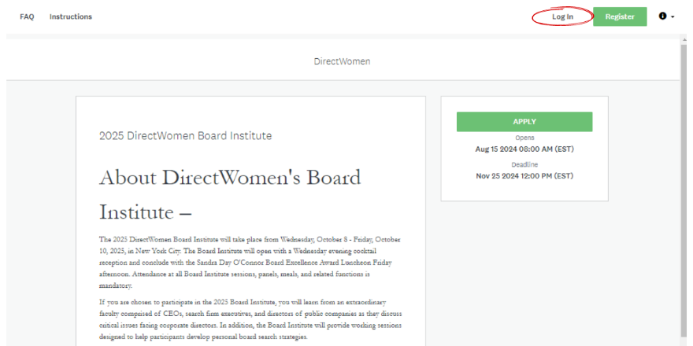

Step 1 – Click the “Register” button
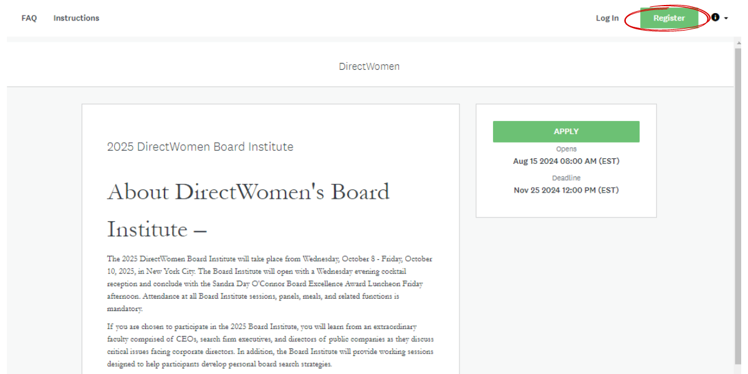
Step 2 – Enter your credentials and click “Create Account.” Please take note of the email address and password you used to create this account.
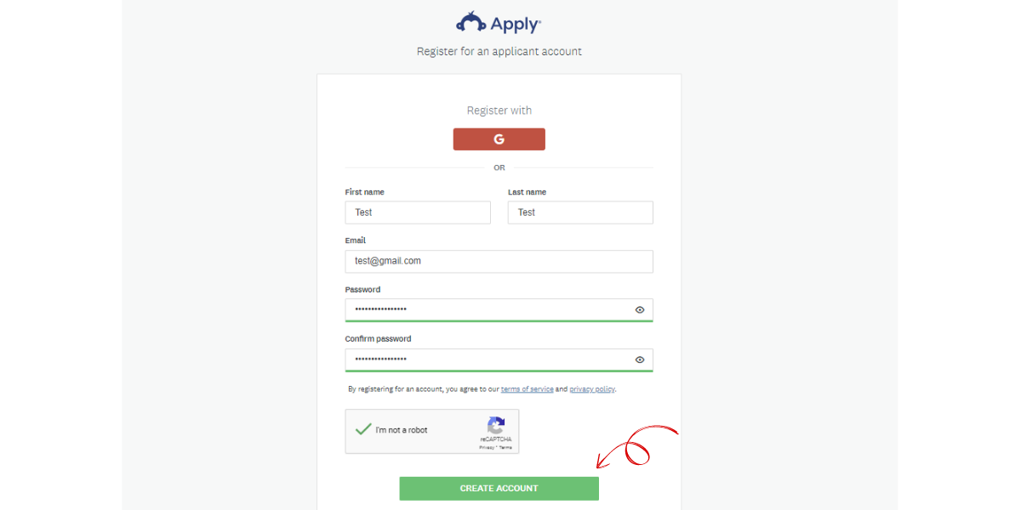
Step 3 – You will receive an email prompting you to verify your email address to successfully create your account. Please follow the steps in this email. If you do not receive an email, check your spam, junk, and/or other folder(s).
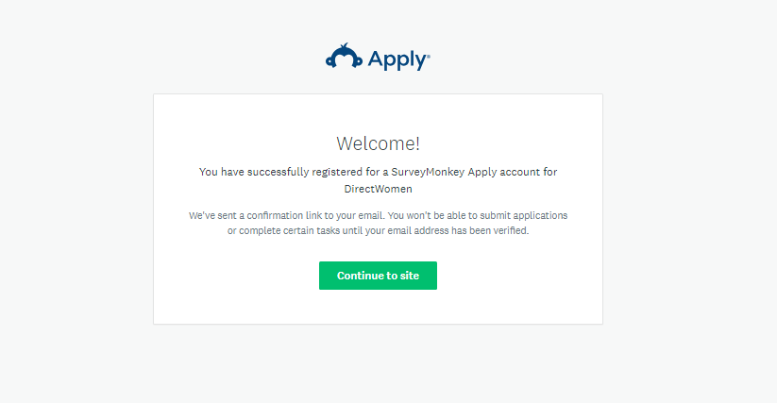
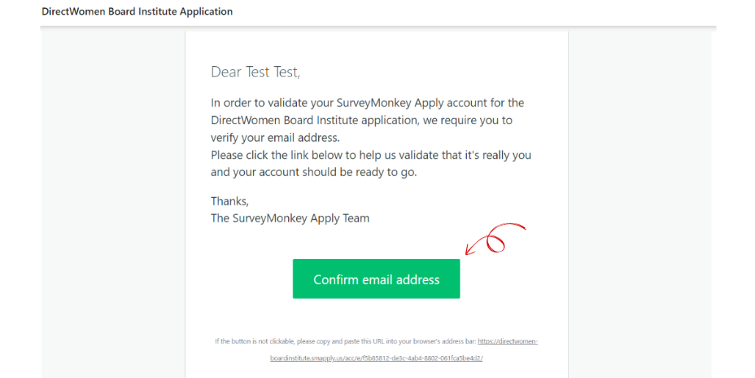
Step 4 – Return to the SurveyMonkey Apply site and follow the prompts until you reach the page to “Apply.”
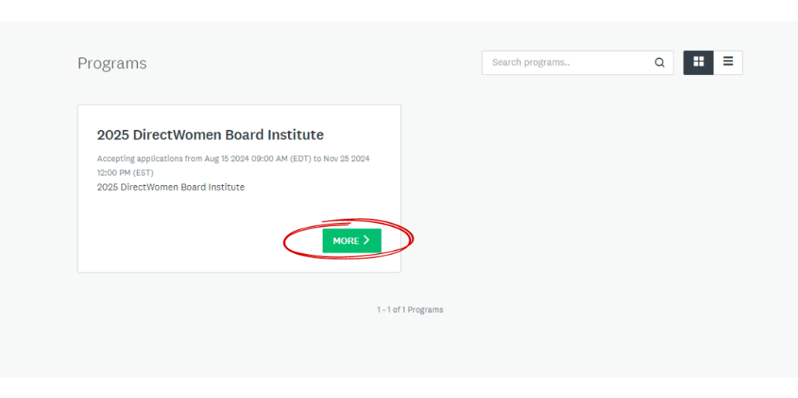
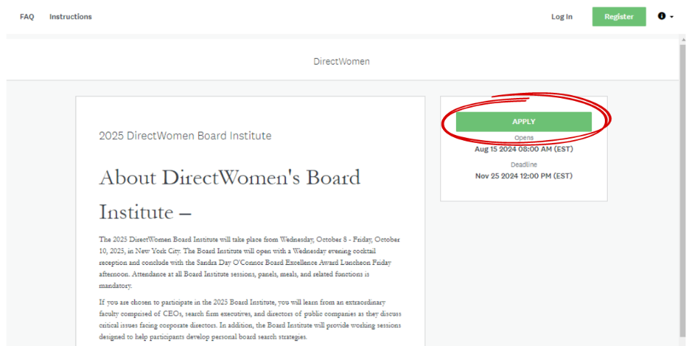
- Complete the application forms.
The application “forms” include the following: Saving Your Application, Contact Information, Education, Additional Information, Employment, and Board and Management Experience. Please note that you can save and return to your application at any time using the email and password that you used to create your account. Be sure to click the “Save and Continue Editing” button before exiting the application if you have not completed the form.
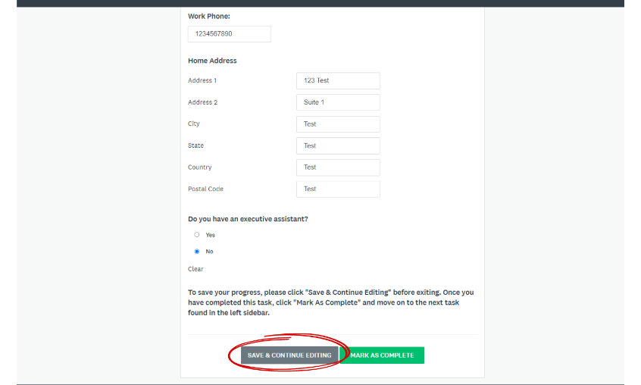
- Upload your headshot and resume
Please make sure that your resume includes your basic contact information and employment information, including your current position/title, major contributions in your current job, your two most recent jobs, education history, and leadership positions or industry associations.
- Submit at least two letters of recommendation.
Letters of recommendation are given substantial weight in the selection process. We strongly recommend that the letters of recommendation come from CEOs and/or board members who have seen you in the boardroom and are not connected to DirectWomen. The letters should address your level of readiness for board service and one or more of the following:
- Your business skills and judgment
- Your business operations experience
- Your risk management experience
- Your experience with investor-shareholder relations
Applicants are responsible for requesting two letters of recommendation and ensuring that the letters are received by 12:00 Noon ET on November 25, 2024. You may submit the letters by uploading them to the application yourself or by having your references email the letter to Yessenia Echevarria at yechevarria@directwomen.org. Any letters sent to DirectWomen staff will be uploaded to your application so you can confirm they have been received. Letters may be addressed to the "DirectWomen Selection Committee."
- Confirm your availability for the 2025 Board Institute.
- Pay the $500 application fee.
Please submit your $500 non-refundable application fee. You will be emailed a receipt when payment is received.
- Submit your application.
Please note that the completion of all tasks does not lead to your application being automatically submitted. You must click “Submit” to successfully submit your application for consideration,
If you have any questions or concerns about the application or selection process for the Board Institute, please contact Yessenia Echevarria at yechevarria@directwomen.org or 833.239.6636.

