Frequently Asked Questions

How do I start my application?
If you already have a SurveyMonkey Apply account, simply “Log In.”
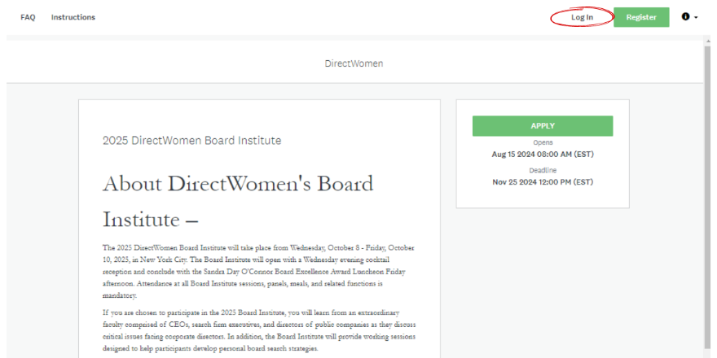
If you have never used SurveyMonkey Apply, start by creating an account.
Step 1 – Click the “Register” button
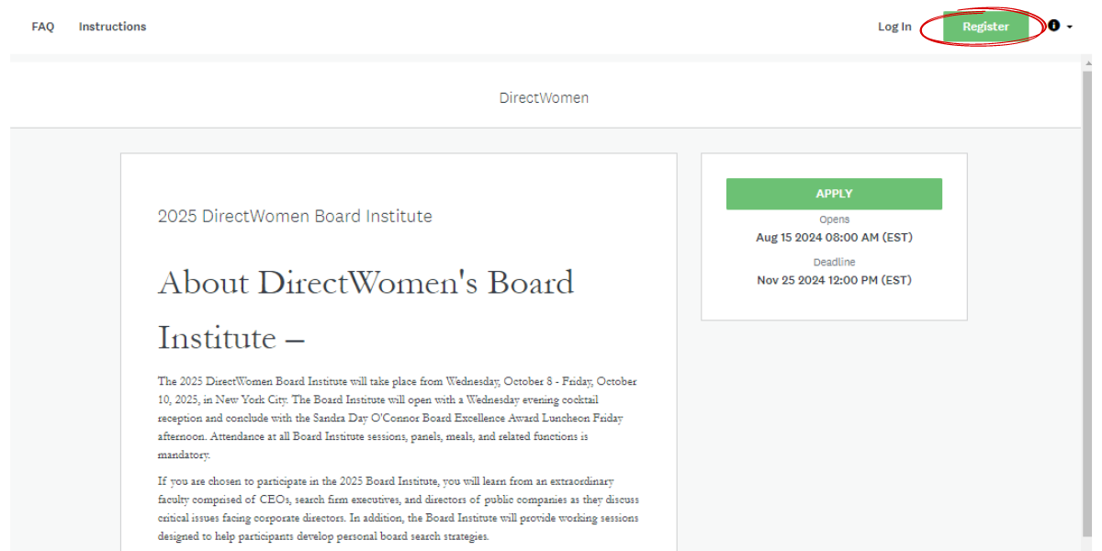

Step 2 – Enter your credentials and click “Create Account.” Please take note of the email address and password you used to create this account.
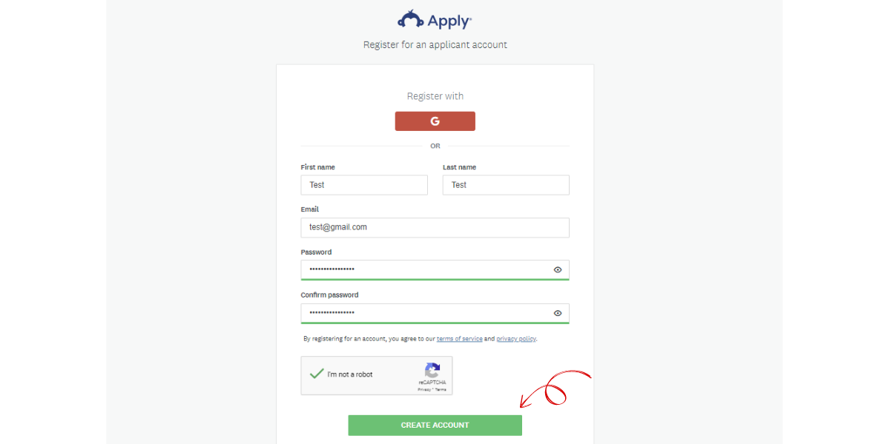
Step 3 – You will receive an email prompting you to verify your email to successfully create your account. Please follow the steps in this email. If you do not receive an email, check your spam, junk, and/or other folder(s).
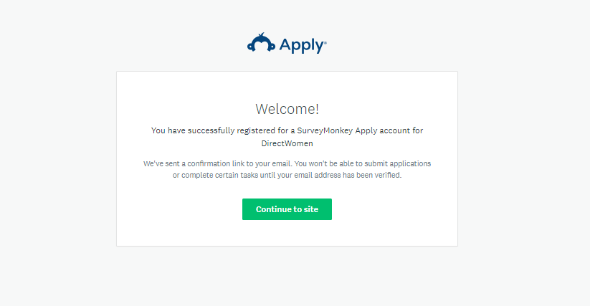
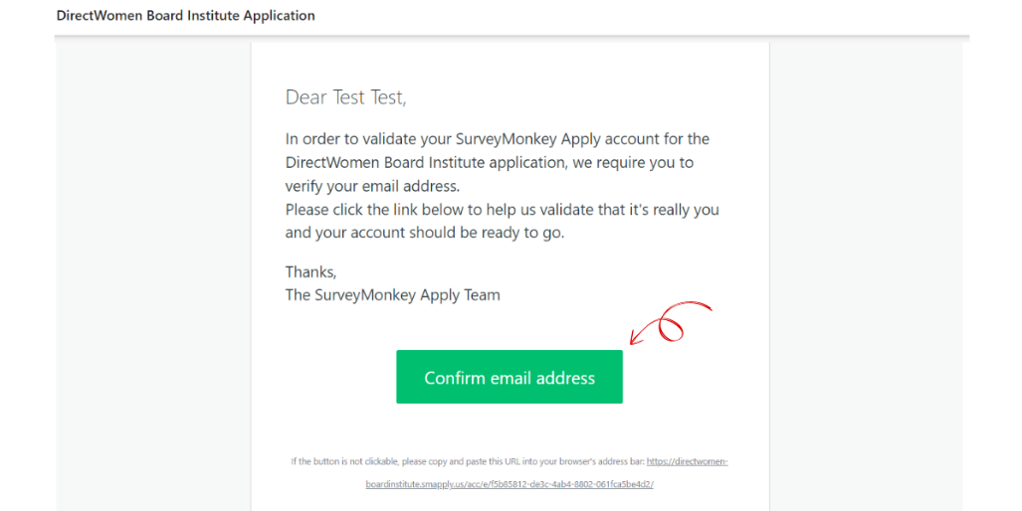
Step 4 – Return to the SurveyMonkey Apply site and follow the prompts until you reach the page to “Apply.”
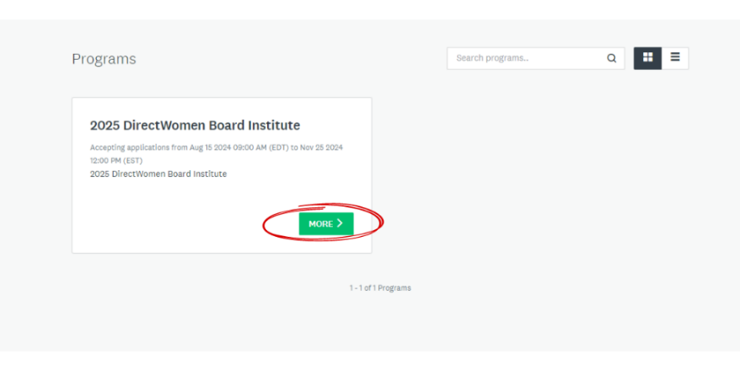
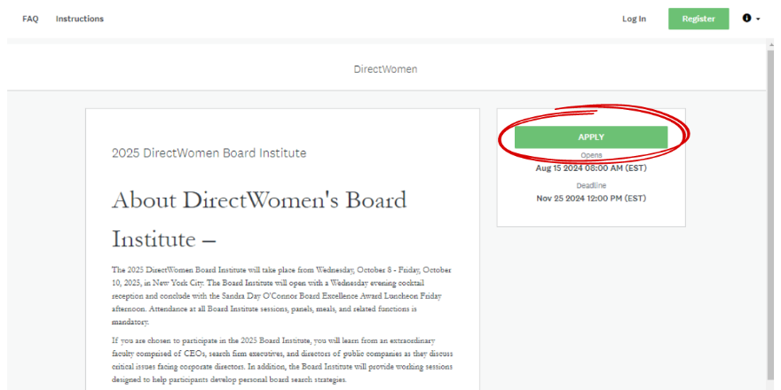

I’m having trouble logging in.
If you have never used SurveyMonkey Apply, please make sure you have followed the steps to create an account and verified your email address as prompted. If you have already started the application and cannot get back in, please make sure you are trying to login with the email address you used to create the account. You can also try resetting your password using the link on the log in page.
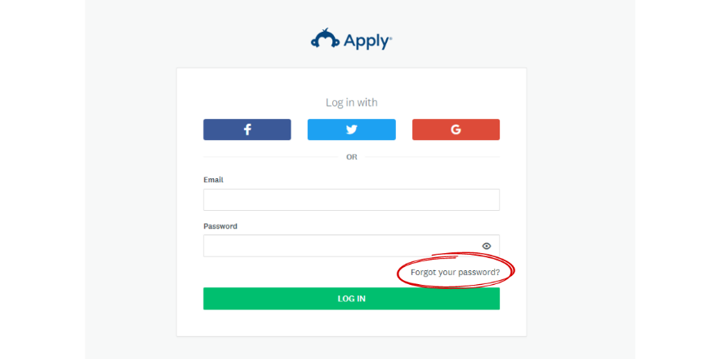
If none of these options work, please contact Yessenia Echevarria at yechevarria@directwomen.org or 833.239.6636.

How can I avoid losing my progress when exiting the application?
Click the “Save & Continue Editing” button at the bottom of the forms and “Mark As Complete” button to complete each individual task. Please do not clear your cache. If you clear your cache, there is a possibility that you will erase your progress and have to restart the application.
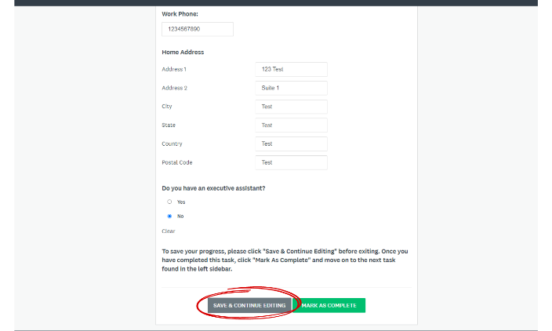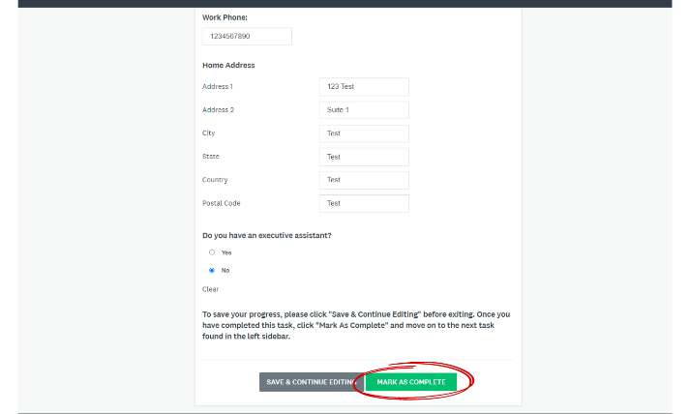
To confirm that the progress has been saved, please verify that the circle next to the task turns partially or fully green.
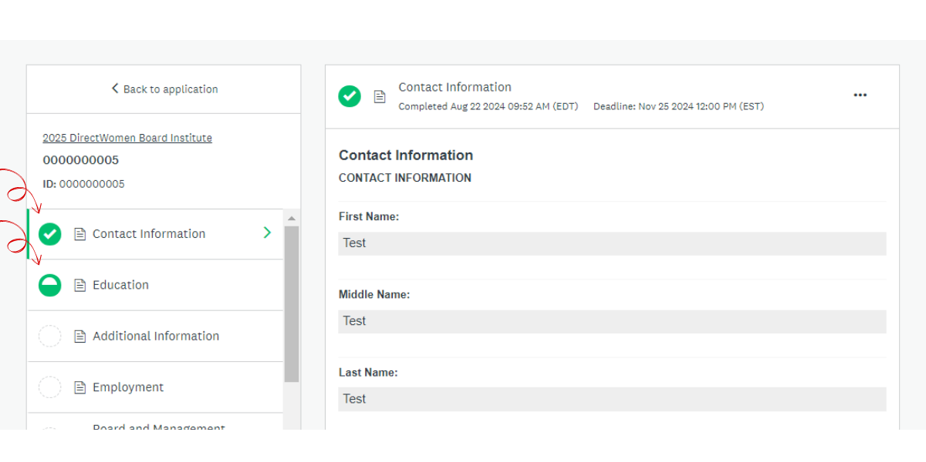

What are the dates of the 2025 Board Institute?
The Board Institute will begin with the Welcoming Cocktail Reception at 6:30 p.m. ET on October 8, 2025, and will conclude with the Sandra Day O’Connor Board Excellence Award Luncheon on October 10, 2025, at 2:00 p.m. ET. Attendance at all Board Institute activities is mandatory.

Where will the 2025 Board Institute take place?
The Board Institute and the Sandra Day O'Connor Board Excellence Award Luncheon will take place in New York City.

When will I know if I have been selected for the Board Institute Class?
All applicants will be notified of their application status by early February 2025.

What is the tuition for the Board Institute?
There is a $500 non-refundable application fee. Tuition for those selected to participate in the Board Institute is $10,000, which includes two nights hotel accommodations and most meals during the Board Institute.

What does the Board Institute program entail?
At the Board Institute, the class meets with faculty comprised of CEOs, C-suite executives, search firm executives, and directors of public companies to discuss key issues facing corporate directors about governance, corporate purpose, risk management, and other relevant topics. The class also meets with DirectWomen honorees and alumnae, many of whom have extensive board experience. Class members will participate in exercises to develop a board-specific value proposition and search strategy.

Who is typically selected for the Board Institute class?
Women selected for the Board Institute are considered board-ready and have the experience, independence, and business judgment required for effective public company board service. Please see the press releases announcing the 2024 Board Institute classes for examples of women previously selected for the Board Institute class.

If I already serve on a board, am I eligible to participate in the Board Institute?

Many women who serve on smaller company boards or private company boards find that participating in the DirectWomen Board Institute is very helpful, particularly if they aspire to serve on a public company board or need to develop a personal value proposition and search strategy.

Is there an age restriction to participate in the Board Institute?

There is no age restriction. However, many public company boards have mandatory retirement ages and therefore seek directors who can serve for 10-15 years before reaching retirement age. We recommend that women apply for the Board Institute before they retire from their day jobs to allow the most flexibility in their board search.

How will I know if DirectWomen has received my letters of recommendation?
DirectWomen staff will upload all letters of recommendation to your application as they are received. You can view all letters under the “Letters of Recommendation” task. Applicants are responsible for ensuring that DirectWomen receives all letters of recommendation before 12:00 Noon ET on November 25.

Where should my references send their letters of recommendation?
All letters should be emailed to Yessenia Echevarria at yechevarria@directwomen.org. Letters may be addressed to the “DirectWomen Selection Committee.” Please note that all letters must be received by the 12:00 noon ET November 25 deadline. Please see the “Letters of Recommendation” section in our Instructions for more information.

My reference sent me their letter of recommendation a couple of days late. Can I still include it in my application?
Unfortunately, DirectWomen cannot consider application materials received after the 12:00 Noon ET November 25 deadline. Incomplete applications will not be considered by the Selection Committee.
If you anticipate that you will not have time to submit all application materials before the application deadline, we recommend that you wait to apply for the 2026 Board Institute. Email Yessenia Echevarria (yechevarria@directwomen.org) if you would like to be notified when the application for the 2026 Board Institute opens next summer.

Can I make edits to my application?
Yes. You can return to view and edit your application until it has been submitted. You will be unable to make any changes to your application after 12:00 Noon ET on November 25.

To edit a task that has already been marked as “completed,” please follow the steps below:
Step 1
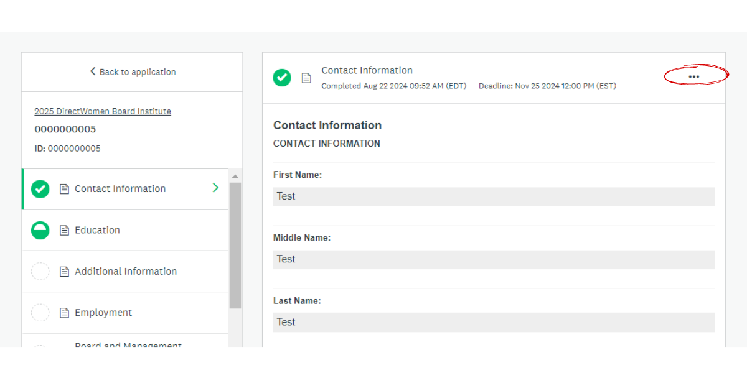
Step 2
